The Standard Module

The standard module is the form factor that governs the design of USC. Each module follows this same basic body plan.

It is 115mm square, with holes that are 4.875mm in diameter and 99mm apart from their centers, and 5mm thick. The hole diameter is a function of the diameter of the neodymium magnets, the flexibility of the medium (typically acrylic), and the thickness and settings of the laser. It is advised to do a test cut first to guarantee a proper friction fit.

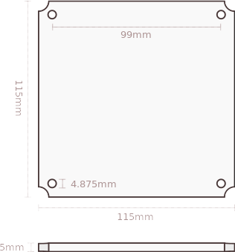

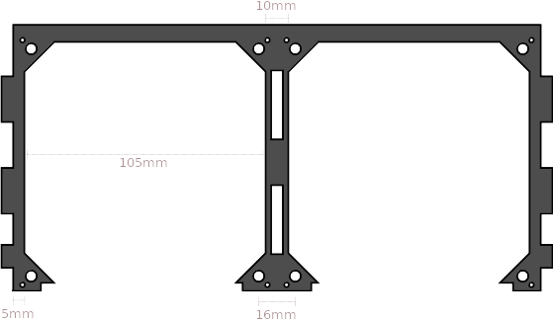
The module fits into the Module Slot. They have the same holes for magnets, 16mm apart where the modules touch. The slots are 105mm square, with a 5mm edge (or 10mm between them).
Containers

A container houses one or more standard modules and provides power and communication through the internal data bus.

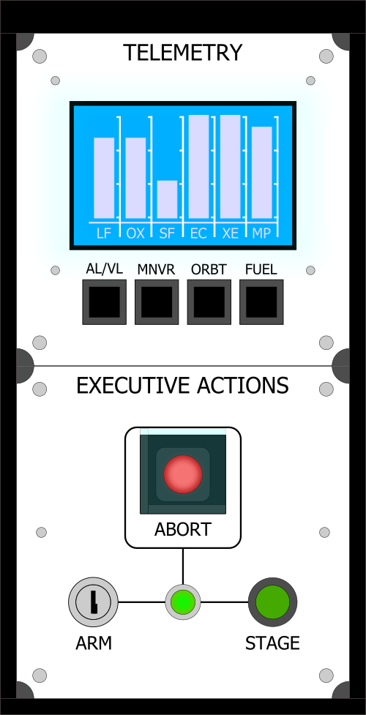

Containers have several measurements in common. Their pieces should all be 5mm thick. They are all 95.8mm tall on the back end. Containers that are two modules deep are 240mm long and 47.5mm tall on the short end. The measurements throughout the containers may not be exact; typically they are a few fractions of a millimeter shorter in order to account for the space needed for the caulk adhesive.

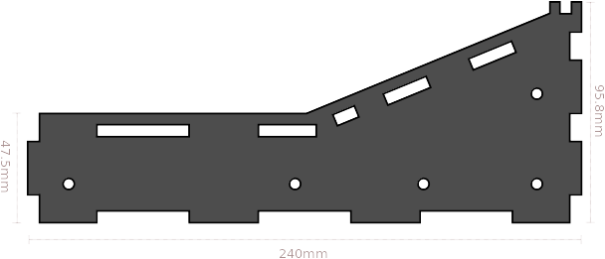
Hubs

Every container has exactly one Hub. A Hub is the core of the controller and supplies the serial connection to the computer and contains KSP-specific firmware.

A single hub consists of a consumer-grade microcontroller, typically Arduino Micro (or Arduino Nano on older USC models) as well as either four or eight connections to the i2c Data Bus to connect modules.

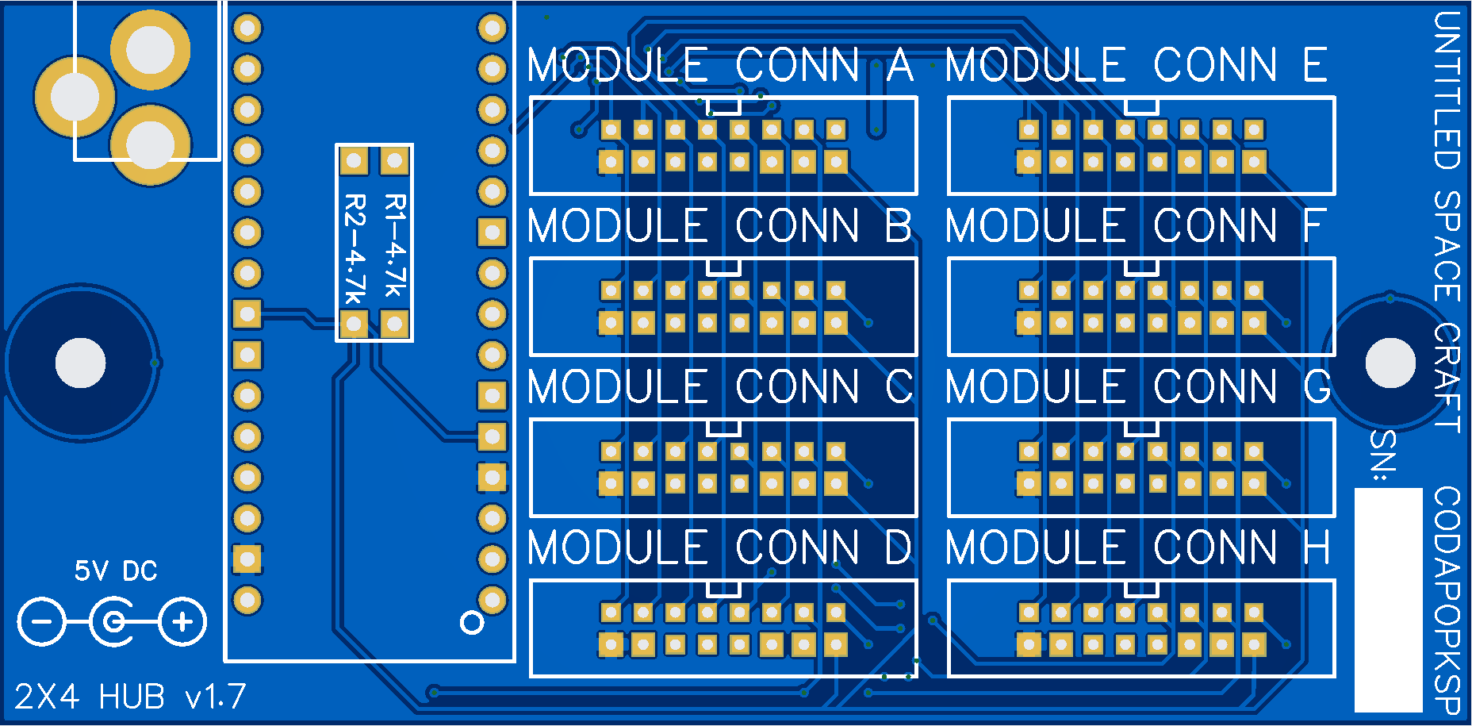

There are two sizes of hubs, Quad (aka: 1x4) and Octo (aka: 2x4). The two hub sizes are identical in every way other than the number of sockets that connect to the i2c bus. The 2.1mm barrel jack is center-positive polarity. The hub PCB is set up to support both Arduino Micro and Arduino Nano interchangeably, but the firmware expects Arduino Micro in order to make use of the HID capability for keyboard emulation (both in KSP Mode and in Emulation Mode).

The microcontroller is powered by the USB connection while the modules are powered by an external 5V PSU that connects via the 2.1mm barrel jack.

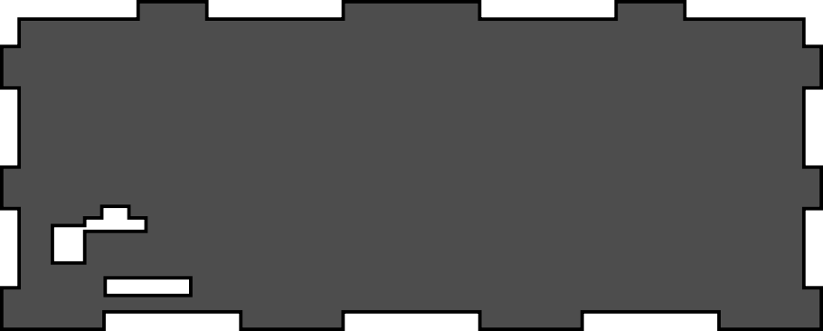

The microcontroller should not be soldered directly to the PCB; it should be socketed with two 1x15 pin header sockets, increasing the height by approximately 8.5mm in order to match the holes in the back of the container.

The PCB itself should have a gap of one standard 3M nut between it and the acrylic below it.

